Data Operations - Sanitization

Definition
# Source: AI Source: Provided by: [Data Path: Persons Table -> ID Column: 1, Name_En Column: Motasem Essam] -> From: [Chatgpt (GPT‑5 Mini)] on [12/10/2025]
Sanitization is the process of cleaning, modifying, or removing unsafe, sensitive, or unwanted parts of data to ensure it is secure, safe, and suitable for use.
• Protects systems from harmful input (e.g., malicious code)
• Ensures data is safe before storage, processing, or display
• Helps prevent security risks such as injection attacks

Key idea:
# Source: AI Source: Provided by: [Data Path: Persons Table -> ID Column: 1, Name_En Column: Motasem Essam] -> From: [Chatgpt (GPT‑5 Mini)] on [12/10/2025]
It’s like filtering out harmful or unnecessary content from data before using or sharing it.

Characteristics of Sanitization
# Source: AI Source: Provided by: [Data Path: Persons Table -> ID Column: 1, Name_En Column: Motasem Essam] -> From: [Chatgpt (GPT‑5 Mini)] on [12/10/2025]
• Removes or neutralizes unsafe input (e.g., scripts, special characters)
• Focuses on security and safety, not just correctness
• Often applied after validation
• Can involve masking, encoding, or stripping data
• Helps protect databases, applications, and users
• Can be automated using software tools or libraries

Sanitization Rules
# Source: AI Source: Provided by: [Data Path: Persons Table -> ID Column: 1, Name_En Column: Motasem Essam] -> From: [Chatgpt (GPT‑5 Mini)] on [12/10/2025]
Definition
Sanitization rules are methods or techniques applied to data to remove, escape, or modify unsafe or sensitive content.
Key idea:
They ensure that even valid data does not harm the system or expose sensitive information.
How Sanitization Works
• Data is received from a user or system
• Sanitization rules process the data
• Unsafe or sensitive parts are removed or modified
• Clean and safe data is stored or used

Types of Sanitization
# Source: AI Source: Provided by: [Data Path: Persons Table -> ID Column: 1, Name_En Column: Motasem Essam] -> From: [Chatgpt (GPT‑5 Mini)] on [12/10/2025]
- Input Cleaning – Removes unwanted or harmful characters
o Example: Removing <script> tags from user input
- Escaping / Encoding – Converts special characters into safe formats
o Example: < → &lt; to prevent code execution
- Trimming – Removes unnecessary spaces
o Example: " Ali " → "Ali"
- Masking – Hides sensitive data
o Example: Credit card → **** **** **** 1234
- Filtering – Allows only safe or approved values
o Example: Username can contain only letters and numbers
- Normalization – Standardizes data format
o Example: Converting text to lowercase → ALI → ali

Examples
# Source: AI Source: Provided by: [Data Path: Persons Table -> ID Column: 1, Name_En Column: Motasem Essam] -> From: [Chatgpt (GPT‑5 Mini)] on [12/10/2025]
- User Input Form:
Input:
<script>alert("hack")</script> Ali
After sanitization:
Ali
- Login System:
• Username: admin → admin ✅
• Input: <b>Omar</b> → Omar ✅

Advantages
# Source: AI Source: Provided by: [Data Path: Persons Table -> ID Column: 1, Name_En Column: Motasem Essam] -> From: [Chatgpt (GPT‑5 Mini)] on [12/10/2025]
• Protects systems from security threats (e.g., XSS, SQL injection)
• Ensures safe data handling and storage
• Improves data consistency and usability
• Helps protect user privacy (masking sensitive data)

Disadvantages
# Source: AI Source: Provided by: [Data Path: Persons Table -> ID Column: 1, Name_En Column: Motasem Essam] -> From: [Chatgpt (GPT‑5 Mini)] on [12/10/2025]
• May remove useful data if too strict
• Requires careful rule design
• Can add processing overhead
• Not a replacement for validation (both are needed)

Example Section
# Source: AI Source: Provided by: [Data Path: Persons Table -> ID Column: 1, Name_En Column: Motasem Essam] -> From: [Chatgpt (GPT‑5 Mini)] on [12/10/2025]
A website collects user comments and sanitizes them before saving:
User Input:
Name Comment
Ali <script>alert("x")</script> Nice post!
Sara Great article
After Sanitization:
Name Comment
Ali Nice post!
Sara Great article
• Harmful script is removed from Ali’s comment
• Extra spaces are removed from Sara’s comment
• Data is now safe to store and display

Validation vs Sanitization

Definition
# Source: AI Source: Provided by: [Data Path: Persons Table -> ID Column: 1, Name_En Column: Motasem Essam] -> From: [Chatgpt (GPT‑5 Mini)] on [12/10/2025]
Validation ✅
Validation is the process of checking whether data is correct, complete, and follows predefined rules before it is accepted.
Sanitization 🧼
Sanitization is the process of cleaning or modifying data to remove unsafe, harmful, or sensitive content before it is used or stored.

Key Idea
# Source: AI Source: Provided by: [Data Path: Persons Table -> ID Column: 1, Name_En Column: Motasem Essam] -> From: [Chatgpt (GPT‑5 Mini)] on [12/10/2025]
• Validation: Is the data correct?
• Sanitization: Is the data safe?

Purpose
# Source: AI Source: Provided by: [Data Path: Persons Table -> ID Column: 1, Name_En Column: Motasem Essam] -> From: [Chatgpt (GPT‑5 Mini)] on [12/10/2025]
• Validation: Prevent incorrect or invalid data
• Sanitization: Prevent harmful or unsafe data

When It Happens
# Source: AI Source: Provided by: [Data Path: Persons Table -> ID Column: 1, Name_En Column: Motasem Essam] -> From: [Chatgpt (GPT‑5 Mini)] on [12/10/2025]
• Validation: First step (before accepting data)
• Sanitization: After validation (before storing/using data)

What It Checks / Does
# Source: AI Source: Provided by: [Data Path: Persons Table -> ID Column: 1, Name_En Column: Motasem Essam] -> From: [Chatgpt (GPT‑5 Mini)] on [12/10/2025]
Validation:
• Format (email, phone)
• Range (age limits)
• Required fields
• Uniqueness
• Consistency
Sanitization:
• Removes scripts or harmful code
• Trims spaces
• Encodes special characters
• Masks sensitive data
• Filters allowed content

Example
# Source: AI Source: Provided by: [Data Path: Persons Table -> ID Column: 1, Name_En Column: Motasem Essam] -> From: [Chatgpt (GPT‑5 Mini)] on [12/10/2025]
Input Data:
<script>alert("hack")</script> userexample.com
After Validation: ❌
• Email is invalid → rejected
After Sanitization (if valid input):
Ali → Ali
• Unsafe code removed
• Extra spaces trimmed

Output Result
# Source: AI Source: Provided by: [Data Path: Persons Table -> ID Column: 1, Name_En Column: Motasem Essam] -> From: [Chatgpt (GPT‑5 Mini)] on [12/10/2025]
• Validation: Accept ✅ or Reject ❌
• Sanitization: Cleaned and safe data ✔

Relationship
# Source: AI Source: Provided by: [Data Path: Persons Table -> ID Column: 1, Name_En Column: Motasem Essam] -> From: [Chatgpt (GPT‑5 Mini)] on [12/10/2025]
Validation and Sanitization work together, not separately:
👉 Validation ensures quality
👉 Sanitization ensures security
✔ Best practice:
Validate → then Sanitize → then Store/Use

Quick Comparison Table
# Source: AI Source: Provided by: [Data Path: Persons Table -> ID Column: 1, Name_En Column: Motasem Essam] -> From: [Chatgpt (GPT‑5 Mini)] on [12/10/2025]
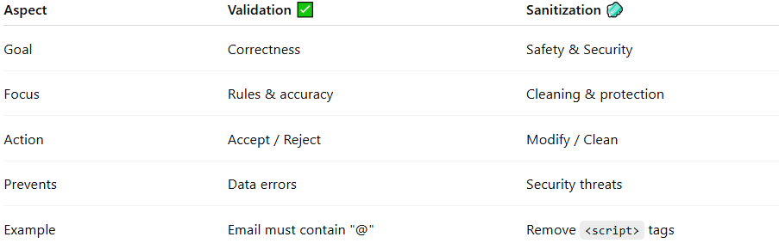
Aspect | Validation ✅ | Sanitization 🧼
Goal | Correctness | Safety & Security
Focus | Rules & accuracy | Cleaning & protection
Action | Accept / Reject | Modify / Clean
Prevents | Data errors | Security threats
Example | Email must contain "@" | Remove <script> tags

